Time-optimal Drift Initiation

John Alsterda, Qizhan Tam, Mauro Salazar (Should I be an author?)

# Introduction

Prior research [1] has focused on autonomous driving in the drift regime, when the vehicle is near equilibrium drift conditions. This work has not, however, addressed the problem of transitioning a vehicle into this drift equilibrium from a normal driving state. The goal of this project is to develop an optimal trajectory planner and controller through nonlinear programming to accomplish such a transition. The maneuver this project will focus on is the Scandinavian Flick, which is characterized by the saturation (oversteering) of the rear wheels of the car while its inertia carries it through a corner [2]. We will perform simulations as the verification step.

# Vehicle Dynamics Model

## Four-wheels Model

Delete this subsection: useless. We use it for simulation.

We use the four-wheels model shown in Fig. 1 to determine the desired final states of the vehicle, just as Goh et al. [1] did for their drift stabilization and tracking work. ­We also employ this model in IPOPT to calculate a state and input trajectory for the Scandinavian Flick via nonlinear optimization. The velocity states in Fig. 1 are sideslip $β$, yaw rate $r$, and vehicle speed $V$.

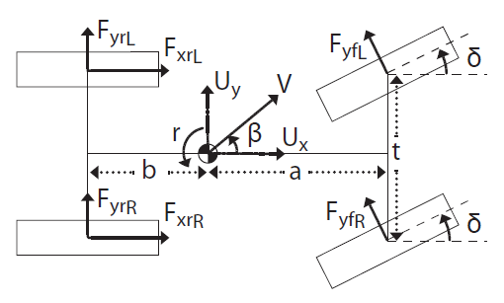

1. Parameters of the four-wheel model [1].

## Single-track ‘Bicycle’ Model

We use a simplified model where each of the front and rear wheel pairs are coupled and assumed to have identical forces acting upon them [Reference].

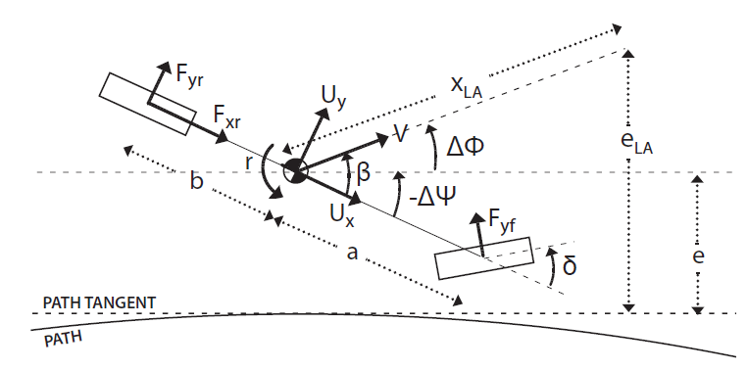

1. Parameters of the simplified single-track model [1]

# Problem Formulation

## State and Input Variables

The state variables of this optimization problem are the vehicle position $(N, E)$, heading angle relative to North, Φ, longitudinal velocity $U_{x}$, lateral velocity $U_{x}$, and yaw rate $r$. The control inputs are the steering angle, δ, and the rear-wheel torque, $τ_{xr}$. We need a figure and a model formulation here.

We compute the drifting equilibrium by... This occurs when the equations of motion, derived from the four-wheel model (why not 2?), equate to $0=\dot{r}=\dot{U_{x}}=\dot{U_{y}}$. The final states are further constrained by the final position and heading of the vehicle as depicted in Figure 3 for the initialization of drift-tracking a circular trajectory. Additional state and input constraints obtained from the Dynamic Design Lab’s MARTY [Reference?] platform will be used for this project. Write the model.

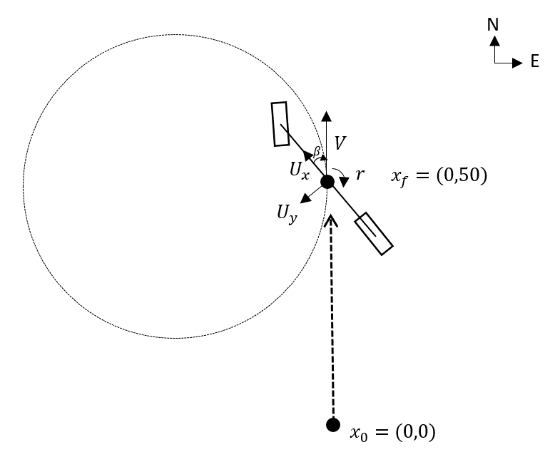

1. Sketch of the desired initial and final positions of the vehicle.

## Cost Minimization

The proposed cost function is the weighted sum of the squared L2 norms of the final state deviations from? with the first derivative of the control inputs penalized as a measure of driving comfort. Rewrite.

$${J_{N}}^{*}=\min_{δ, τ_{r}}\left\{{\left\|x_{N}-x_{f}\right\|}^{2}+{\left\|U_{N}-U_{f}\right\|}^{2}+{\left(Φ_{N}-Φ_{f}\right)}^{2}+{\left(r_{N}-r_{f}\right)}^{2}+\frac{1}{N}\sum_{k=0}^{N}{{(\dot{δ_{k}}}^{2}+{\dot{{τ_{xr}}_{k}}}^{2})}\right\}$$

Include part on implementation.

# Preliminary results

Initial solutions to the state and input trajectories are promising. What solution is this?

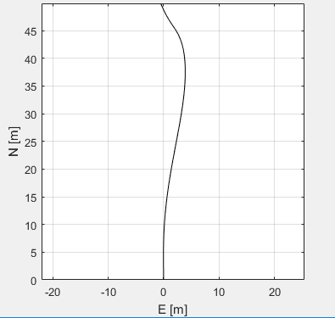

1. Optimal path in the East-Nortth reference frame.

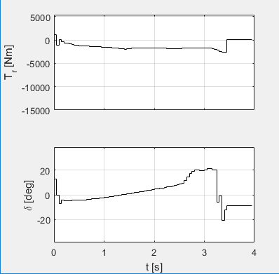

1. *Optimal* torque and steering input trajectories.

##### References

* + - 1. J. Y. Goh and J. C. Gerdes, "Simultaneous stabilization and tracking of basic automobile drifting trajectories," 2016 IEEE Intelligent Vehicles Symposium (IV), Gothenburg, 2016, pp. 597-602.
      2. E. Velenis, P. Tsiotras and J. Lu, “Modeling Aggressive Maneuvers on Loose Surfaces: The Cases of Trail-Braking and Pendulum-Turn"Modeling aggressive maneuvers on loose surfaces: The cases of Trail-Braking and Pendulum-Turn," 2007 European Control Conference (ECC), Kos, 2007, pp. 1233-12